**Exercise 10: Online Bookstore – Configuring Content Negotiation**

Business Scenario:

Support different media types (JSON, XML) for your bookstore's RESTful services.

1. **Content Negotiation:**

* I configured Spring Boot to support content negotiation by adding dependencies in pom.xml file.:

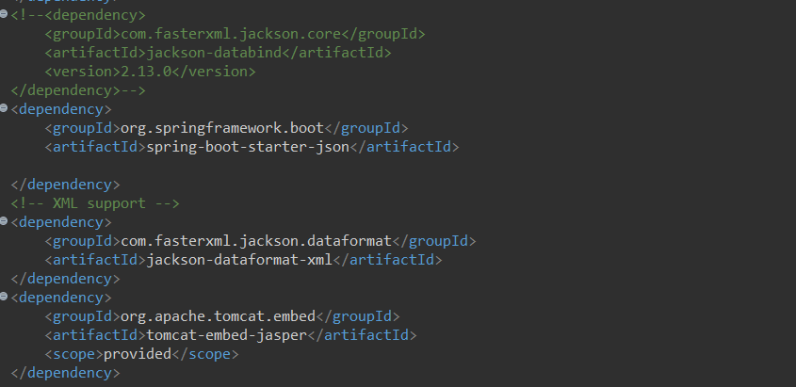

1. **Accept Header:**
   * Implement logic to produce and consume different media types based on the Accept header.

I created a WebCongif class:

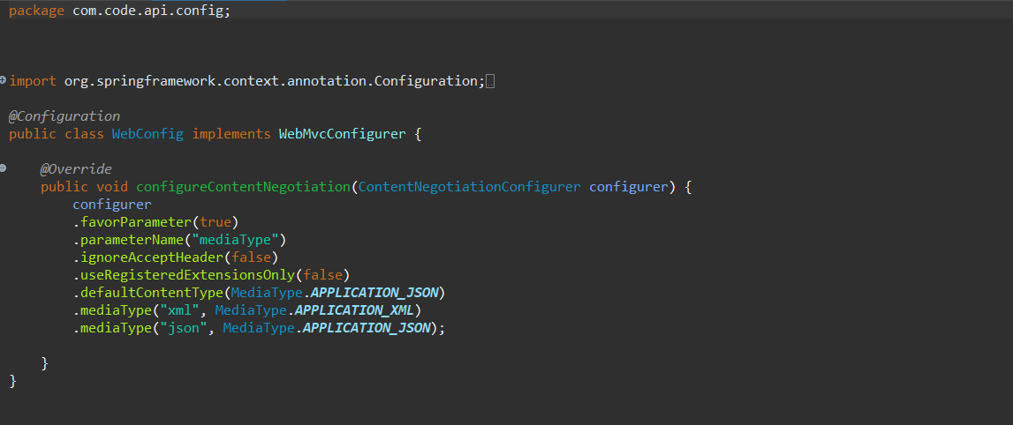

Produce: returning the output.

Consumes: gives input.

Setting up the BookController class:

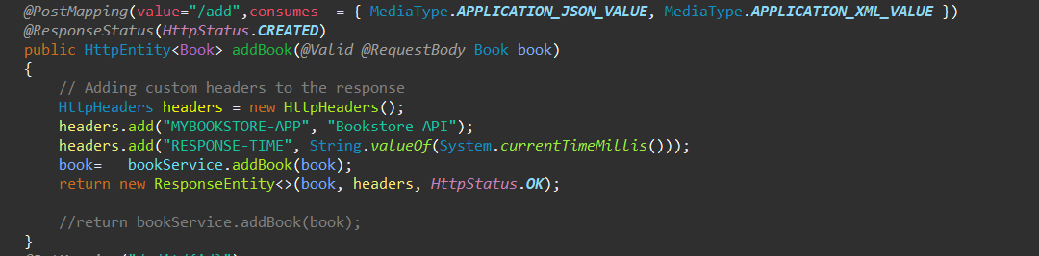

**Output:**

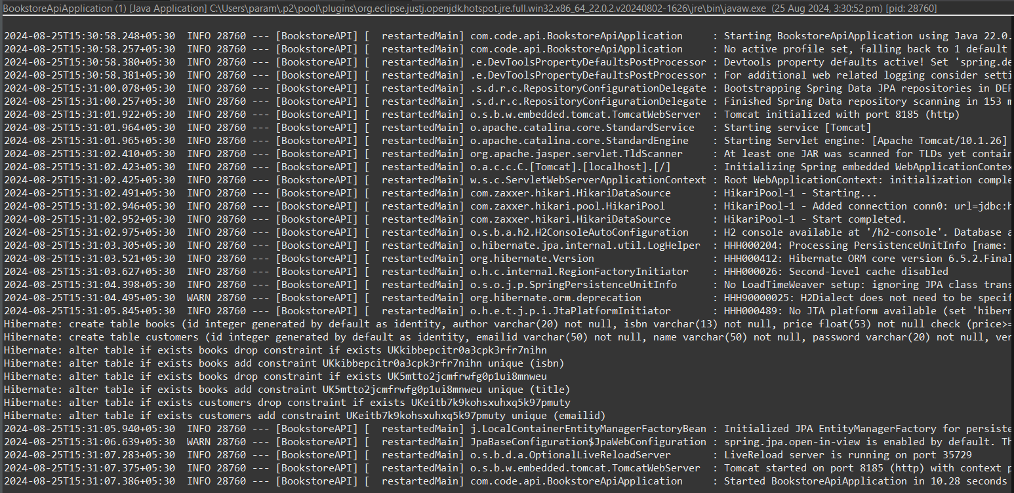

POST(Add books):

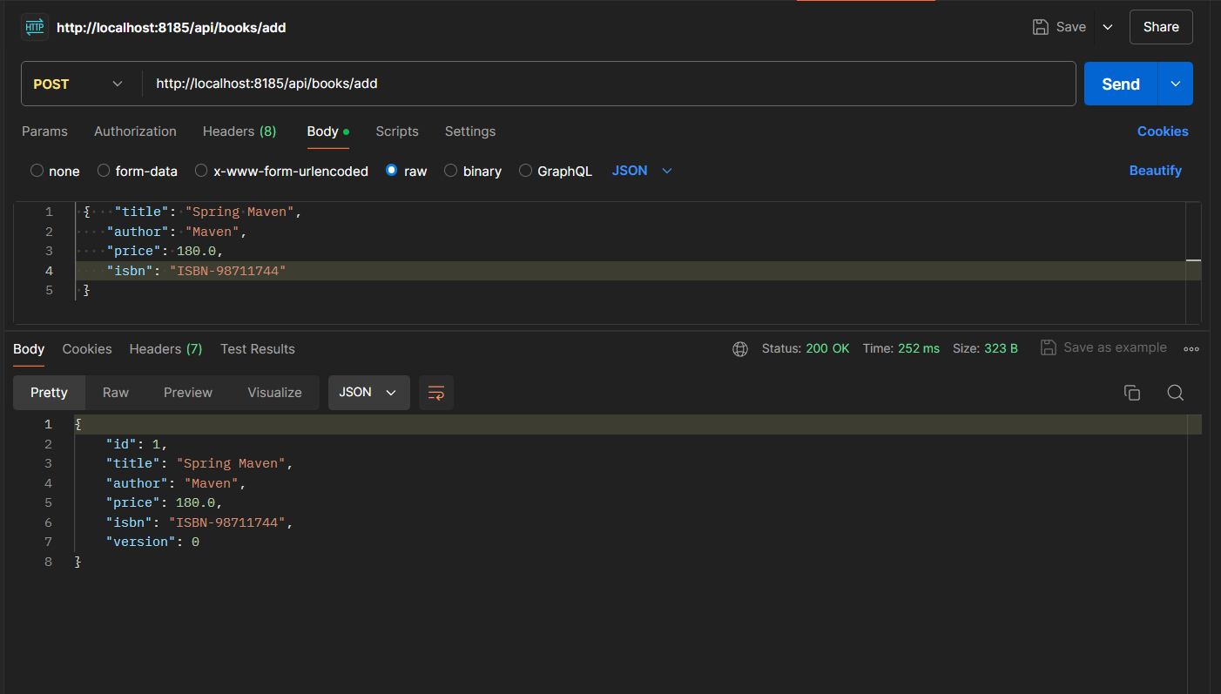

In Header providing Key and Value for xml format view:

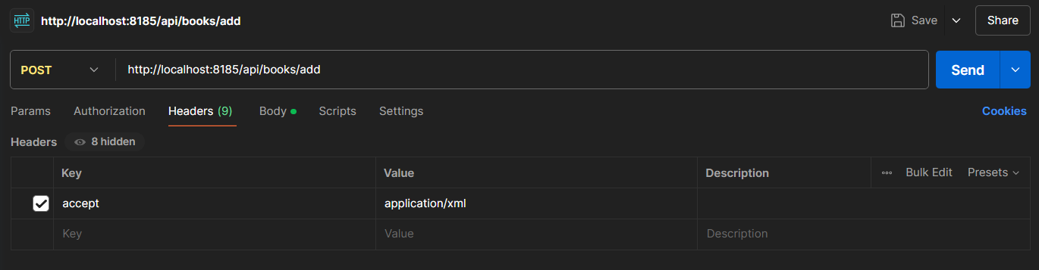

XML Format:

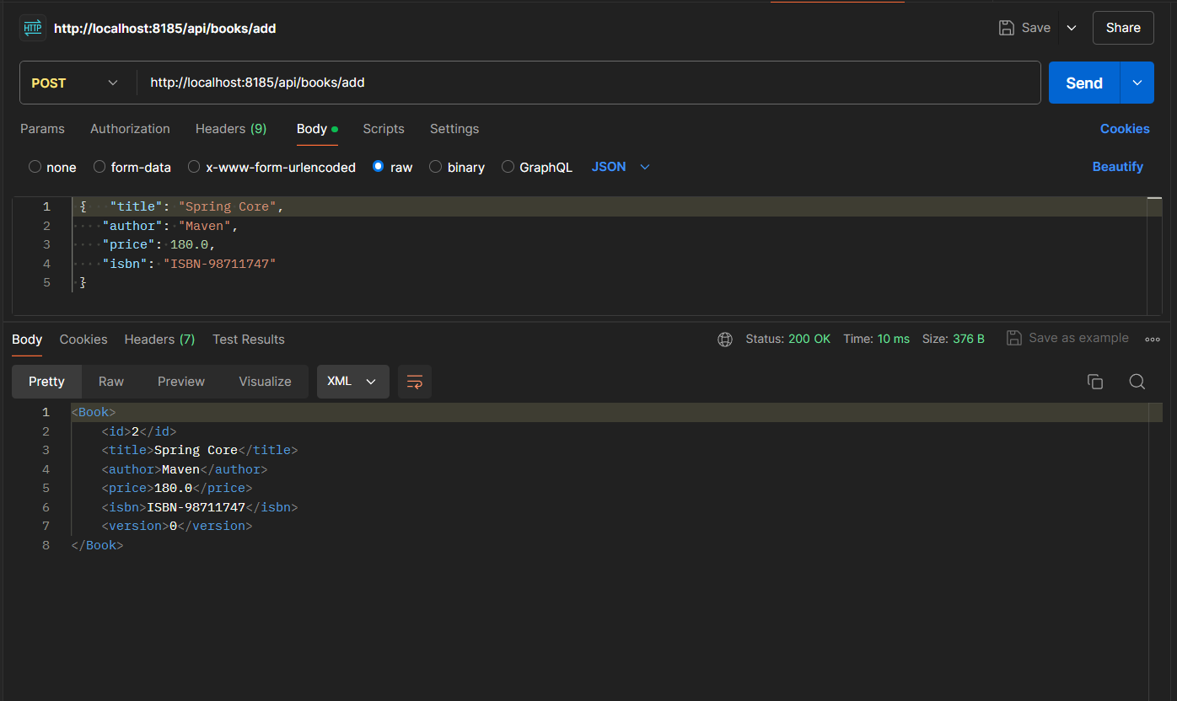

GET:

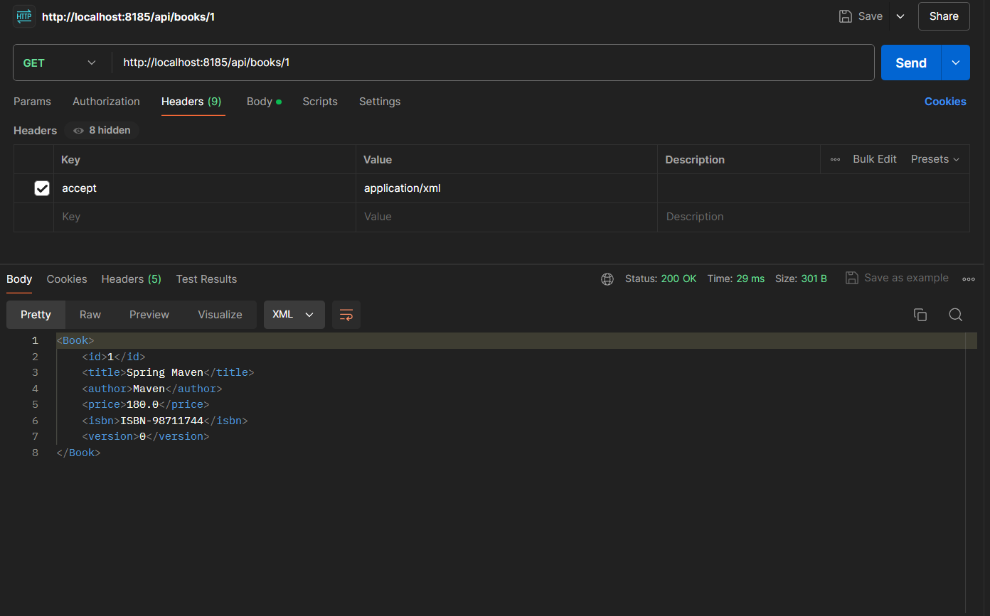

GET all books in XML format:

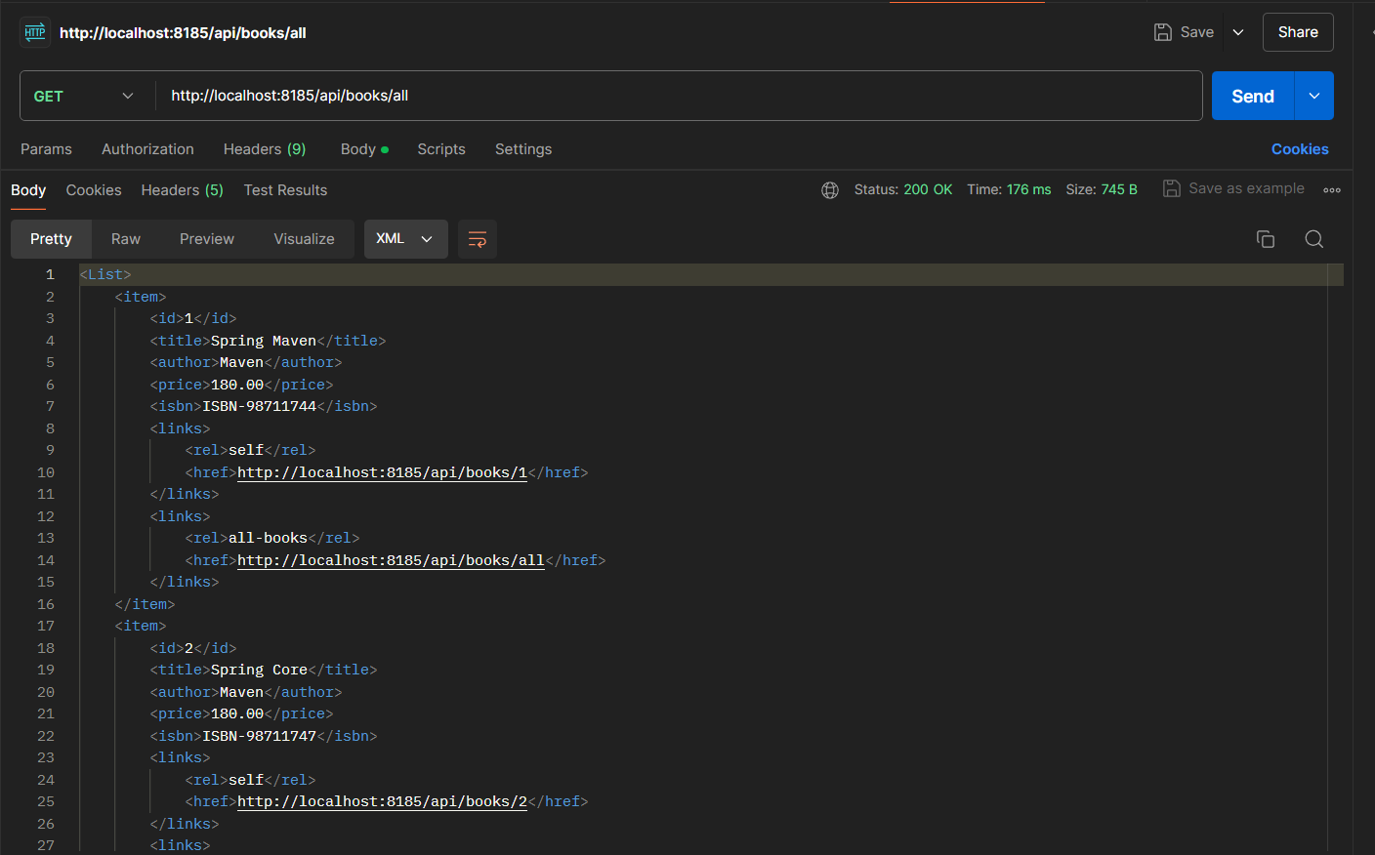

Removing the check-box from accept:

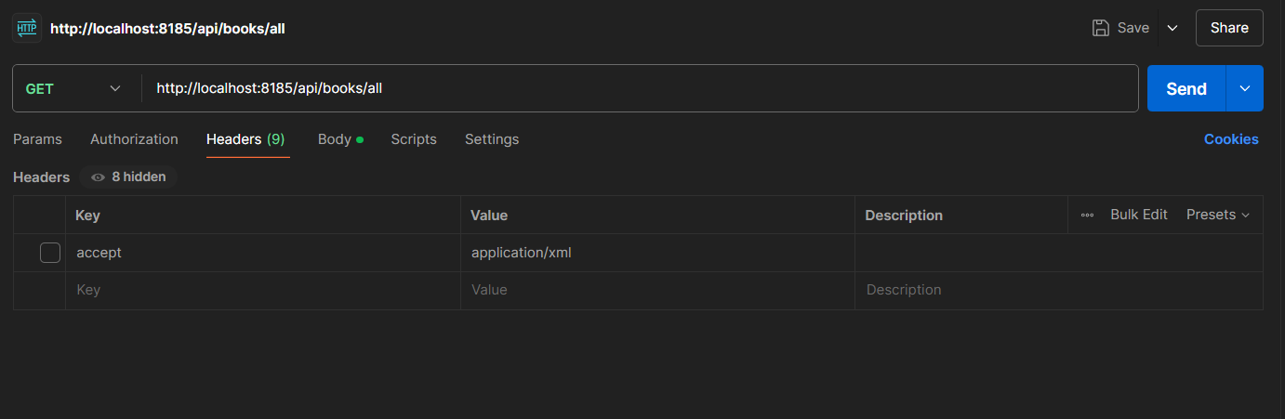

Output is by default in Json format:

